Maths: Geometry, Algebra and Data Handling (Statistics)
- Developing greater confidence and speed answering arithmetic questions using formal and informal mental calculation methods.
- Developing greater confidence in applying mathematical understanding to problem solving and reasoning questions.
- Learning how the angles in shapes and lines can relate to each other.
- Learning how to decode algebraic statements to find mystery values.
- Learning how to interpret data in tables, line graphs and pie charts.

Reading: Using a variety of text extracts
- Developing an understanding of inference, as well as summarising and predicting from fiction, non-fiction and poetry texts.
- Using evidence to support comprehension answers
- Using skimming and scanning for key vocabulary and evidence.
- Developing speed in answering comprehension questions, especially for Year 6.
Writing:
- Applying knowledge of punctuation, sentence structures, tenses and vocabulary to a range of writing genres, including letter writing, setting and character descriptions, non-fiction repots and balanced arguments.
- Revising grammar terminology and the function of particular words, phrases and punctuation within sentences.

Science: Investigating Materials
- Learning about solids, liquids and gases and how materials can undergo reversible and non-reversible changes in which their state may change.
- Learning about the properties of different materials and how they influence how and what materials are used for.
- Using their knowledge of materials to plan and conduct an experiment to test a hypothesis
- Using scientific equipment to take measurements and record observations, before drawing conclusions.

French: Chez moi (My home)
- Using previous vocabulary and grammar
- Learning the vocabulary to talk about where they live: asking and answering questions, talking about the location of their home, the type of home they live in and rooms in their homes.

Geography:
- Learning about how the environment is affected by water and air pollution and how microplastic nurdles develop and impact wildlife.
- Learning about the link between waste and
pollution, and how the idea of
‘Reduce, reuse and recycle’ can
help.

PE:
i) Netball (Mondays)
ii) Rounders (Wednesdays)

Art, Design and Technology:
- Creating art using recycled materials
- Exploring the use of, and effects that can be created with, watercolour paints

PSHE: Managing change
Learning about positive and negative changes we may experience, how people’s views and feelings may change over time, how friendships may change, and how to cope with changes we experience.
Homework:
- 5 reads
- TT Rockstars weekly
- Spelling practise inc homework sheet and Spelling Frame website practice
- Mathletics tasks
- Y6 SATs Revision Packs (Y6 only)

RE: Journeys
Learning about pilgrimage,
including the Haj, and other journeys of faith in Buddhism and Christianity.
Computing:
- Using ICT to create their own presentation (supporting work in other areas of the curriculum)

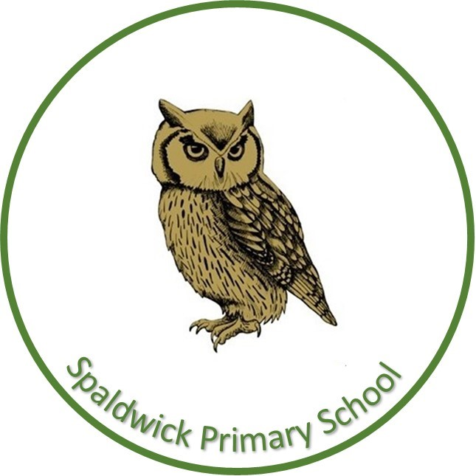
Spaldwick Primary School,
where every day is a chance
to learn and succeed.

Navigators Year 5/6
Summer 1

PE: Monday and Wednesday
Library: Friday

Topic linked dates: Earth Day - 22nd April
World Oceans Day - 8th June

Theme:
‘Global Warming’
(Learning about the impact
we can have on our environment)

The Big Questions
What is Global Warming and what is pollution?
How do oil spills affect the ocean?
What are biodegradable items?
How can we help reduce waste?
How would purchasing food
sourced locally reduce pollution?




