Maths:
- Develop and manipulate knowledge of number
- Explore multiplication and division using manipulatives
- Explore fractions, using real and familiar situations
Reading:
- Phonics groups learning and applying new sounds
- Focus on new sounds, segmenting and blending
- Class book: Horrid Henry
- Daily poem
Writing:
- Focus on creating accurately punctuated sentences: capital letters, full stops and appropriate spacing between words.
- Retell and develop well-known stories
- Add text to stories without words
- Explore and create poems
Science:
- Understand the difference between living things and things that have been alive
- Know animals have offspring
- The basic survival needs of animals
- Identify a variety of common animals
- Describe and compare the structure of common animals
- Identify and name a variety of carnivores, herbivores and omnivores
- Understand environments can change
- Know some animals are endangered
PE: Send and Return
- Explore different methods of sending and returning
- Improve aim and coordination
- Understand rules of games
- Begin to choose and use tactics
Music:
- sing songs and speaking chants and rhymes
- play instruments to represent animals sounds
- create and combine sounds to represent known sounds

Geography:
- Know and locate the continents of the world
- Know and locate the oceans of the world
- Locate where different animals live

Art, Design and Technology:
- Explore a range of materials and colours
- Develop fine motor skills through a range of apparatus
- Create their own animal prints using a given technique
PSHE: Friends and Family
- Understand different family patterns
- Describe what is special about their own families
- Describe the qualities of friendships
- Develop strategies to manage friendships and conflicts

Key Dates:
April
14th – Johnsons Zoo Trip
22nd – TLCs
May
19th – Class photos

Geography:
- Understand human and physical geography
- Study similarities and differences in geography
- Name and locate 7 continents
- Name and locate 5 oceans
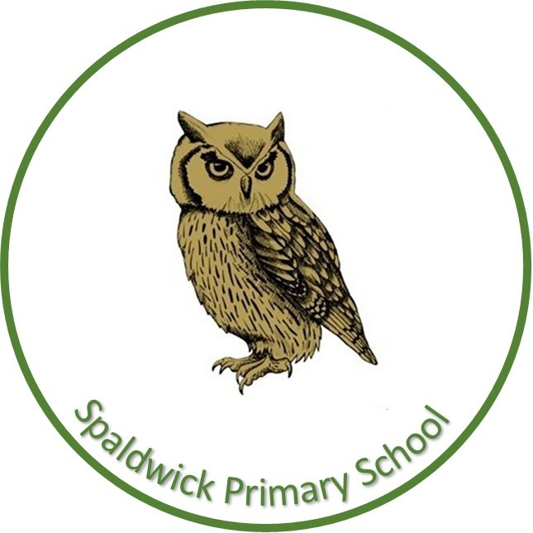
Spaldwick Primary School,
where every day is a chance to learn and succeed.

Pathfinders Year 1
Summer 1
Forest School: Monday
PE: Tuesday and Thursday
Library: Tuesday

Going Wild!
Based around humans and animals, with a science focus. Exploring living and non-living things through to classifying birds, fish, amphibians, reptiles and mammals. A particular focus on looking after animals in a domestic and wild environment.

Big questions:
- What do animals need to survive?
- What do animals eat?
- Where do different animals come from?
- What happens when environments change?

