Maths: Fractions and decimals, Money
- Comparing fractions and decimals
- Equivalent fractions and decimals
- Money values
- Adding money
Reading: When Fishes Flew
- Building fluency
- Summarising and comprehension skills
- Practising our retrieval, inference and prediction skills
Writing 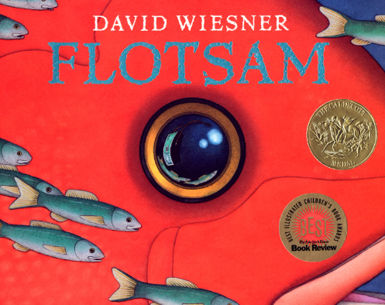 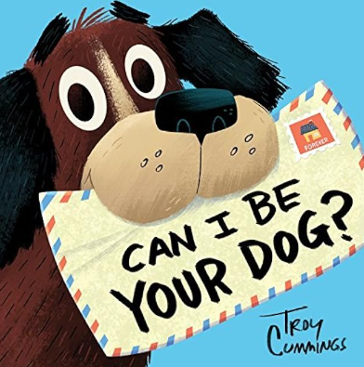
Flotsam | Can I be your dog?
Narrative | Letter writing

Science: Plants
- Functions of different flower parts
- What plants need to live and grow
- Pollination, seed formation and seed dispersal
Geography: Under the canopy
- Rainforest locations
- The four layers of the rainforest
- Food miles
- Rainforest sustainability
History: Under the canopy
- Origin of names
- Mayan heritage

PE – Swimming and Netball
- Working effectively as a team
- Using ball skills to control
- Effectively intercept and tackle
- Swimming a variety of strokes
- Diving (if applicable)

Art: Drawing
- Observational drawings of rainforest animals
- Using oil pastels

PSHE: Personal Safety
- Recognising feeling safe or unsafe
- Asking for help and trusted adults
- Recognising and reporting abuse
- Keeping safe online

Homework:
- 5 reads
- TT rockstars weekly
- Spelling homework sheet
- Mathletics

RE: How do Humanists decide what to believe?
- Scientific evidence
- Challenging claims
- Willingness to adapt and change beliefs

Design Technology:
- Design and create a toy for a tribal child
- Select appropriate materials
- Evaluate design

Year 3/4 - Summer 1
PE: Monday and Wednesday (swimming)
Library: Thursday
Forest School: Friday

Important Dates:
15th April – Swimming starts
22nd April – TLCs
19th May – Class photos
22nd May – School closes (Half term)

The Big Questions:
How would you survive if you lived in the rainforest?
What needs to happen to help save the world’s rainforests?

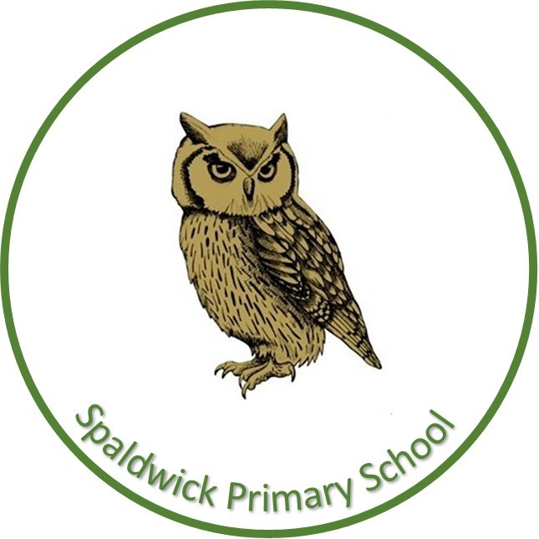
Spaldwick Primary School, where every day is a chance to learn and succeed.

