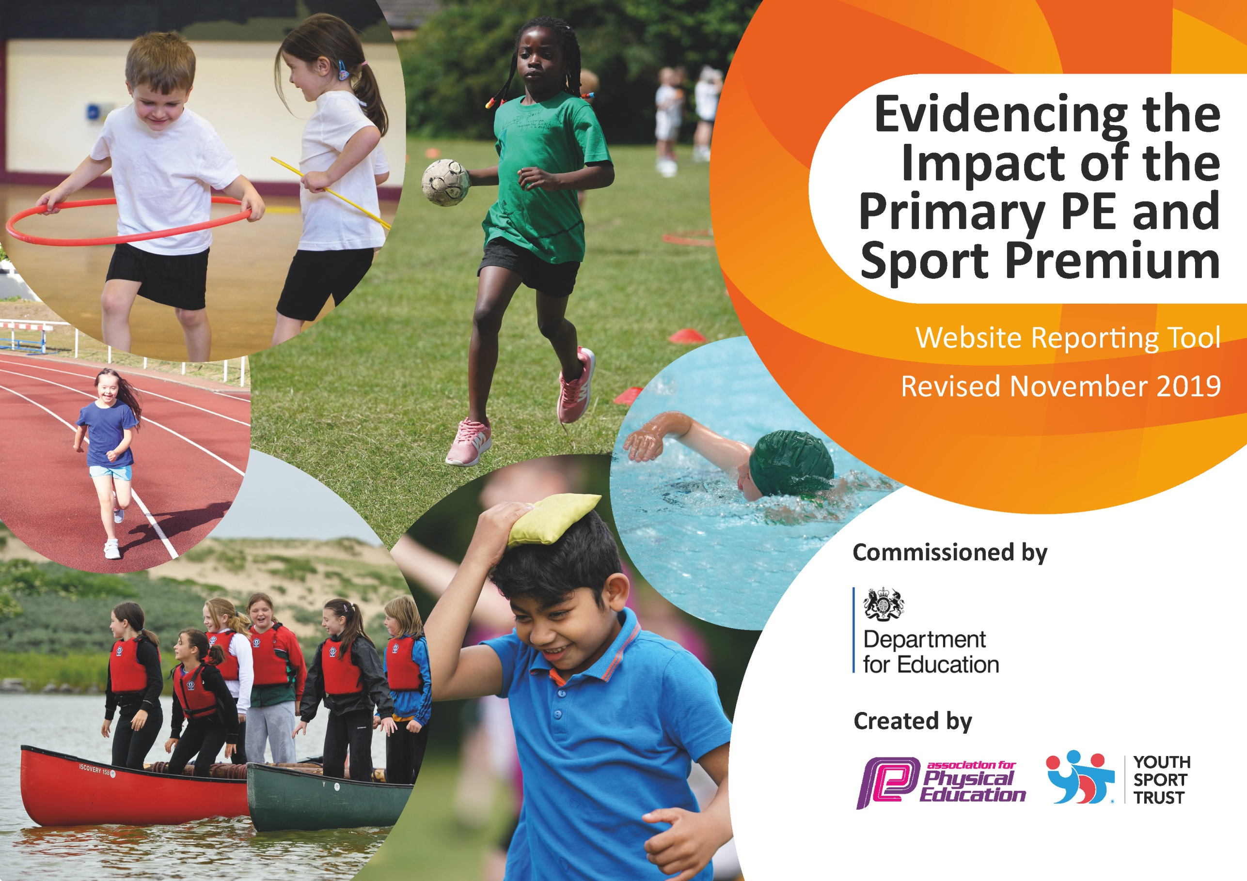
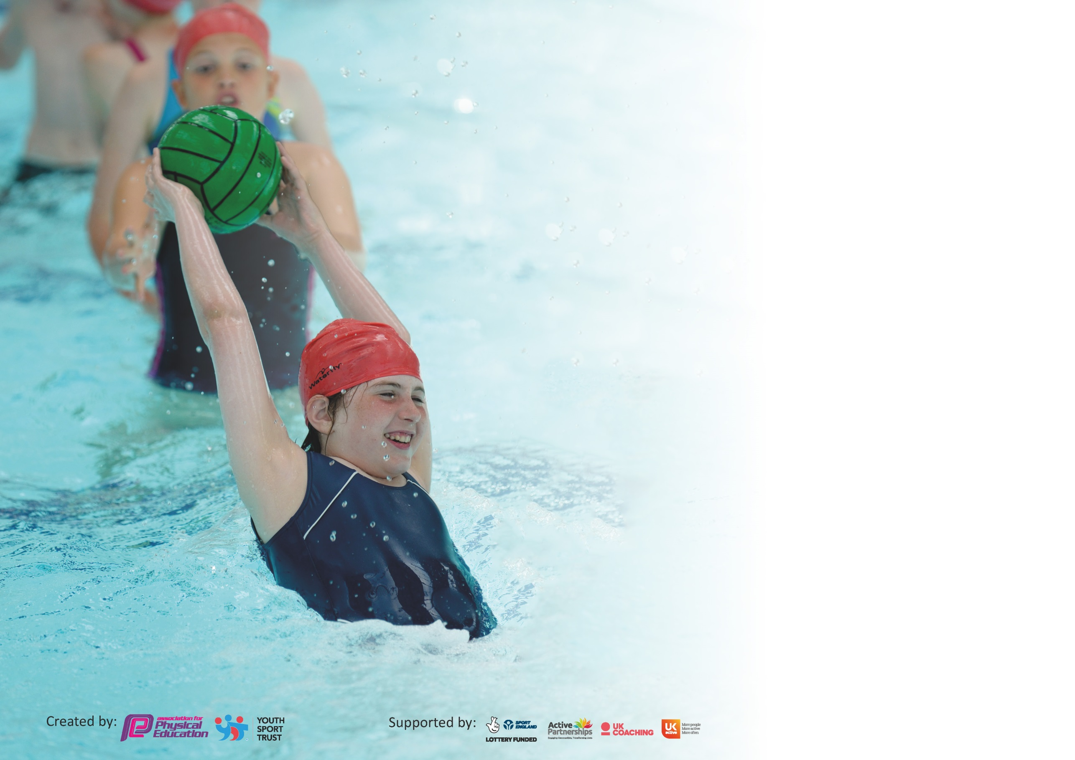

It is important that your grant is used effectively and based on school need. The Education Inspection Framework (Ofsted 2019 p64) makes clear there will be a focus on ‘whether leaders and those responsible for governors all understand their respective roles and perform these in a way that enhances the effectiveness of the school’.

Under the Quality of Education criteria (p41) inspectors consider the extent to which schools can articulate their curriculum (INTENT), construct their curriculum (IMPLEMENTATION) and demonstrate the outcomes which result (IMPACT).

To assist schools with common transferable language this template has been developed to utilise the same three headings which should make your plans easily transferable between working documents.

Schools must use the funding to make additional and sustainable improvements to the quality of Physical Education, School Sport and Physical Activity (PESSPA) they offer. This means that you should
use the Primary PE and Sport Premium to:

- Develop or add to the PESSPA activities that your school already offer
- Build capacity and capability within the school to ensure that improvements made now will benefit pupils joining the school in future years

Please visit gov.uk for the revised DfE guidance including the 5 key indicators across which schools should demonstrate an improvement. This document will help you to review your provision and to report your spend. DfE encourages schools to use this template as an effective way of meeting the reporting requirements of the Primary PE and Sport Premium.

We recommend you start by reflecting on the impact of current provision and reviewing the previous spend.

Schools are required to publish details of how they spend this funding as well as on the impact it has on pupils’ PE and sport participation and attainment by the end of the summer term or by 31st July 2020 at the latest.

We recommend regularly updating the table and publishing it on your website throughout the year. This evidences your ongoing self-evaluation of how you are using the funding to secure maximum, sustainable impact. Final copy must be posted on your website by the end of the academic year and no later than the 31st July 2020. To see an example of how to complete the table please click HERE.

Support for review and reflection - considering the 5 key indicators from DfE, what development needs are a priority for your setting and your pupils now and why? Use the space below to reflect on previous spend and key achievements and areas for development.

Key achievements to date until July 2019: | Areas for further improvement and baseline evidence of need:
- As a school we have consistently been able to provide multiple teams for inter-school KS2 events. Also, we have had recent success in many tournaments including pathways to district/county events.  - We have given opportunities via afterschool clubs for children to participate in a range of school sports.  - Every child at school has been involved in intra-school sporting events.  - We hire transport for sports events meaning these opportunities are more accessible to all pupils (particularly PP children).  - Swimming (including booster sessions) has been provided to every KS2 pupil. | - Use of external bodies or school staff to lead more organised breakfast clubs, lunch time clubs or after school clubs throughout the year.  - To up-level staff and increase confidence in teaching the PE curriculum to ensure delivery of high level PE lessons throughout the school.  - More opportunity for KS1 and lower KS2 children to partake in competitive sports events such as half-termly intra-school tournaments.

Meeting national curriculum requirements for swimming and water safety.
What percentage of your current Year 6 cohort swim competently, confidently and proficiently over a distance of at least 25 metres?  N.B. Even though your pupils may swim in another year please report on their attainment on leaving  primary school at the end of the summer term 2020. | % 14/16 – 87.5%
What percentage of your current Year 6 cohort use a range of strokes effectively [for example, front crawl, backstroke and breaststroke]? | % 14/16 – 87.5%
What percentage of your current Year 6 cohort perform safe self-rescue in different water-based situations? | % 14/16 – 87.5%
Schools can choose to use the Primary PE and Sport Premium to provide additional provision for swimming but this must be for activity over and above the national curriculum requirements. Have you used it in this way? | Yes/No

Action Plan and Budget Tracking
Capture your intended annual spend against the 5 key indicators. Clarify the success criteria and evidence of impact that you intend to measure to evaluate for pupils today and for the future.

Academic Year: 2018/19 | Total fund allocated: £ | Date Updated:
Key indicator 1: The engagement of all pupils in regular physical activity – Chief Medical Officer guidelines recommend that primary school pupils undertake at least 30 minutes of physical activity a day in school |  |  |  | Percentage of total allocation:
 |  |  |  | %
Intent | Implementation |  | Impact
Your school focus should be clear what you want the pupils to know and be able to do and about  what they need to learn and to  consolidate through practice: | Make sure your actions to achieve are linked to your intentions: | Funding allocated: | Evidence of impact: what do pupils now know and what can they now do? What has changed?: | Sustainability and suggested next steps:
All children to be active during break and lunch times.  Sports clubs during lunch times (led by staff or sports leaders). | Line markings purchased for all children to enjoy. Includes activities for boys and girls of all ages. Also includes active board games and education based games. | £3920

Key indicator 2: The profile of PESSPA being raised across the school as a tool for whole school improvement |  |  |  | Percentage of total allocation:
 |  |  |  | %
Intent | Implementation |  | Impact
Your school focus should be clear what you want the pupils to know and be able to do and about  what they need to learn and to  consolidate through practice: | Make sure your actions to achieve are linked to your intentions: | Funding allocated: | Evidence of impact: what do pupils now know and what can they now do? What has changed? | Sustainability and suggested next steps:
The profile of school sport to be valued and promoted. | - Fortnightly, celebration assemblies that celebrate recent sports event success. These results are also published on the school website and sometimes social media.  - Display boards and ‘trophy shelves’ for all visitors, parents and children to see when entering the school.  - Each child belongs to a ‘school house’ in which they compete in during intra-school sports events. |  | - 1. Competing children have had the opportunity to talk about recent sporting success and have been presented with sports certificates. Children can also show out of school success including sometimes non-curricular sports/hobbies.  - 2. Parents have been able to attend assemblies to promote school sport into the local community with pictures/results shared in twitter or in village newsletter.  Also, the notice boards are consistently full of available clubs, matches and results which may include photos of the teams who have been recently competing.

Key indicator 3: Increased confidence, knowledge and skills of all staff in teaching PE and sport |  |  |  | Percentage of total allocation:
 |  |  |  | %
Intent | Implementation |  | Impact
Your school focus should be clear | Make sure your actions to | Funding | Evidence of impact: what do | Sustainability and suggested
what you want the pupils to know | achieve are linked to your | allocated: | pupils now know and what | next steps:
and be able to do and about | intentions: |  | can they now do? What has
what they need to learn and to |  |  | changed?:
consolidate through practice:
To improve staff teaching pedagogy and confidence when teaching PE.  To ensure a range of team and individual sports/ games are being taught in line with the current National Curriculum. | - HSSP subscription  - Yoga training  - PE scheme (PE Hub)  - Other training Courses  - Staff cover for sports events and training (courses).  - Long term and Medium term plans created for teachers. | £5755  £1000  £519  £350  £1740 | - QTS trained PE teachers and coaches work with each teacher during 3 half terms to plan and deliver blocks of work for chosen sports. HSSP also offer ‘twilight’ training sessions for staff. We have opted for dance and gymnastics.  - Provided staff with an accreditation for teaching Yoga to all primary aged children.  - PE scheme offers detailed but used friendly plans for each year group. The plans are part of a progressive scheme of work and build upon one another as year groups progress.  - Courses include safe practice in PE, NFL training, Ofsted framework and KS1 PE.

Key indicator 4: Broader experience of a range of sports and activities offered to all pupils |  |  |  | Percentage of total allocation:
 |  |  |  | %
Intent | Implementation |  | Impact
Your school focus should be clear | Make sure your actions to | Funding | Evidence of impact: what do | Sustainability and suggested
what you want the pupils to know | achieve are linked to your | allocated: | pupils now know and what | next steps:
and be able to do and about | intentions: |  | can they now do? What has
what they need to learn and to |  |  | changed?
consolidate through practice:
Additional achievements:  Increase the variety of sports offered and taught well to children. | - Swimming offered to all K2 pupils (including extra booster sessions) with swimming instructors.  - Bike-ability to year 6 pupils. | £425  (had planned for £850 but have cancelled summer swimming).  £0 | - 1. Provided all children in KS2 with 2-3 sessions of swimming.  Boosters were great at improving water confidence for those that needed as taught very basics by instructor.  - All children that participated successfully completed level 2 bike ability ensuring safety on busy roads and more built-up areas.

Key indicator 5: Increased participation in competitive sport |  |  |  | Percentage of total allocation:
 |  |  |  | %
Intent | Implementation |  | Impact
Your school focus should be clear | Make sure your actions to | Funding | Evidence of impact: what do | Sustainability and suggested
what you want the pupils to know | achieve are linked to your | allocated: | pupils now know and what | next steps:
and be able to do and about | intentions: |  | can they now do? What has
what they need to learn and to |  |  | changed?
consolidate through practice:
 | - Hiring transport (minibus) to and from events.  - St Ives FC football programme and FA affiliation.  - HSSP subscription. | £3000  £420  Subscription cost mentioned in KI3. | - This has enabled more children to take part in HSSP and other sporting festivals, competitive fixtures or tournaments. Previously, many children were unable to take part as we relied on parent transport.  - St Ives and FA affiliation have meant entering boys and girls team into cup competitions and football festivals.  - Subscription allows us to enter sports events such as: Tag Rugby, Hockey Netball, Tennis and Athletics.

Signed off by
Head Teacher:
Date:
Subject Leader:
Date:
Governor:
Date:

